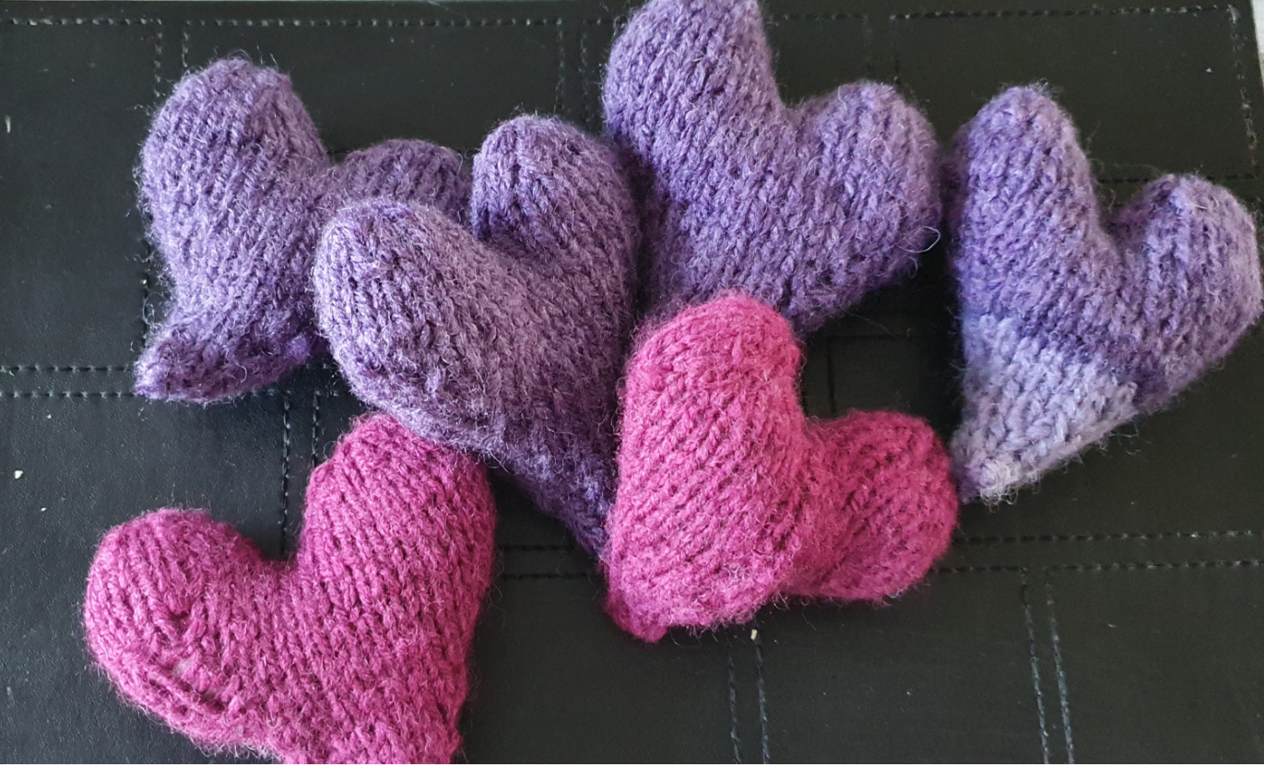

KNITTED HEART

Cast on 6 stitches and knit to secure

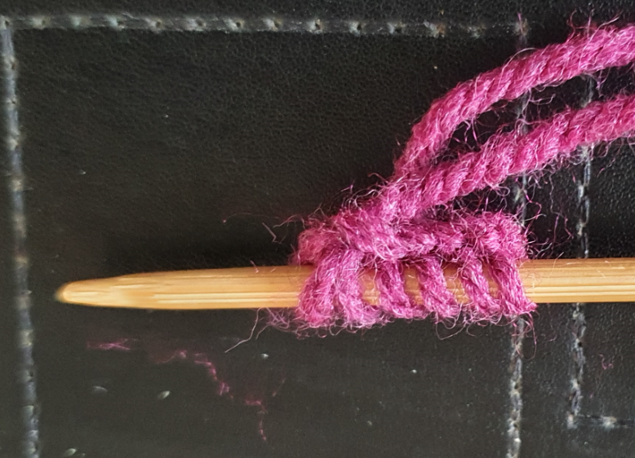

K1, m1,k1,m1, k2,m1,k1,m1,k1 (10 stiches)
Pearl row
K2,m1,k1,m1,k3,m1,k1,m1,k3 (14 stiches)
Pearl row
K3, m1,k1,m1,k5,m1,k1,m1,k4 (18 stiches)
Pearl row
K4,m1,k1,m1,k7,m1,k1,m1,k5 (22 stiches)
Pearl row
K5,m1,k1,m1.k9,m1,k1,m1,k6 (26 stiches)
Pearl row
K6,m1,k1,m1,k11,m1,k1,m1,k7 (30 stiches)
Pearl row
K7,m1,k1,m1,k13,m1,k1,m1,k8) (34 stiches)
Pearl row, Knit row

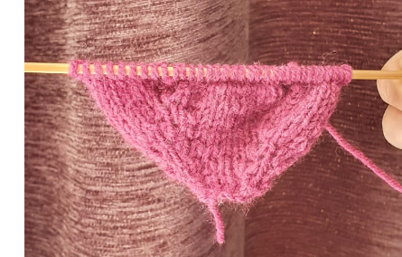

Forming the heart
Pearl 17 stiches and turn around and only work on these stiches (tip hold 17 stiches on stitch holder or use a third needle to continue)
Knit row
Pearl row
K2, k2t,k1,k2t,k3,k2t,k1,k2t,k2 (13 stiches)
Pearl row
K1,k2t,k1,k2t,k3,k2t,k2t (9 stiches)
Attached needle to yarn and pull remaining 9 stiches through needle to form heart shape

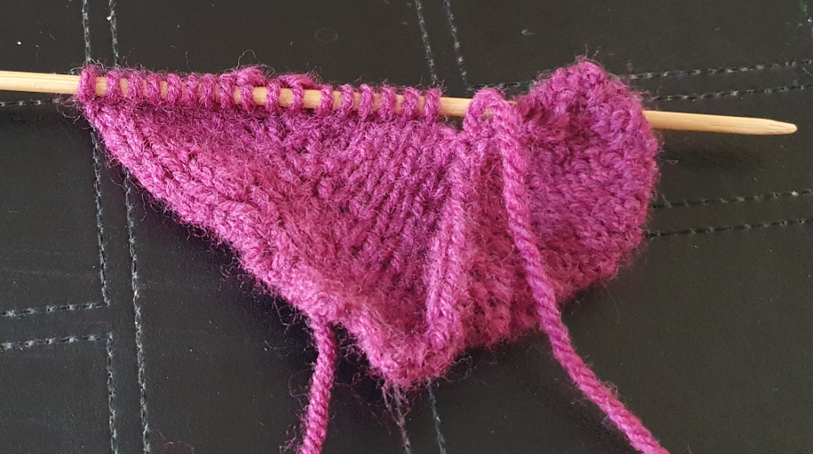

Now work on remaining 17 stiches
Pearl 17 stiches
Knit two
Pearl Row
K2, k2t,k1,k2t,k3,k2t,k1,k2t,k2 (13 stiches)
Pearl row
K1,k2t,k1,k2t,k3,k2t,k2t (9 stiches)
Attached needle to yarn and pull remaining 9 stiches through needle to form heart shape

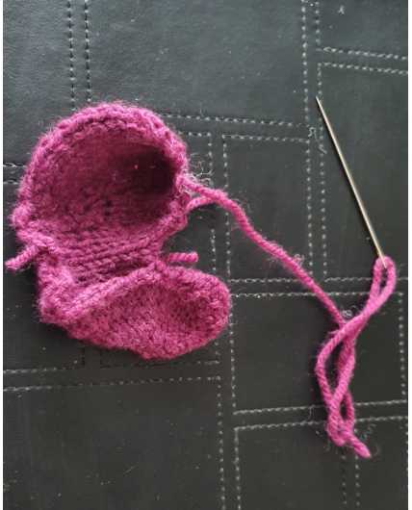

Turn to right side, stuff with toy filling, and sew to secure.

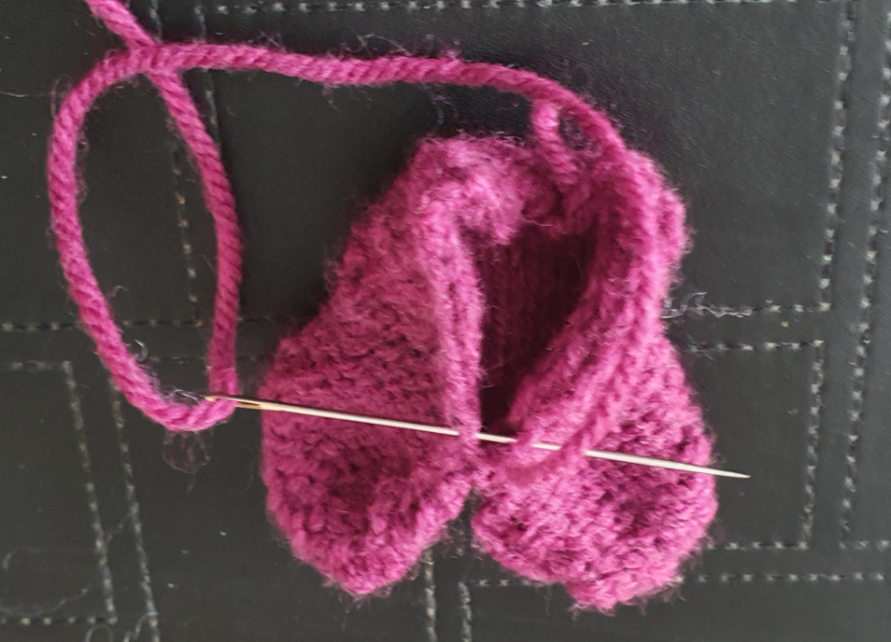

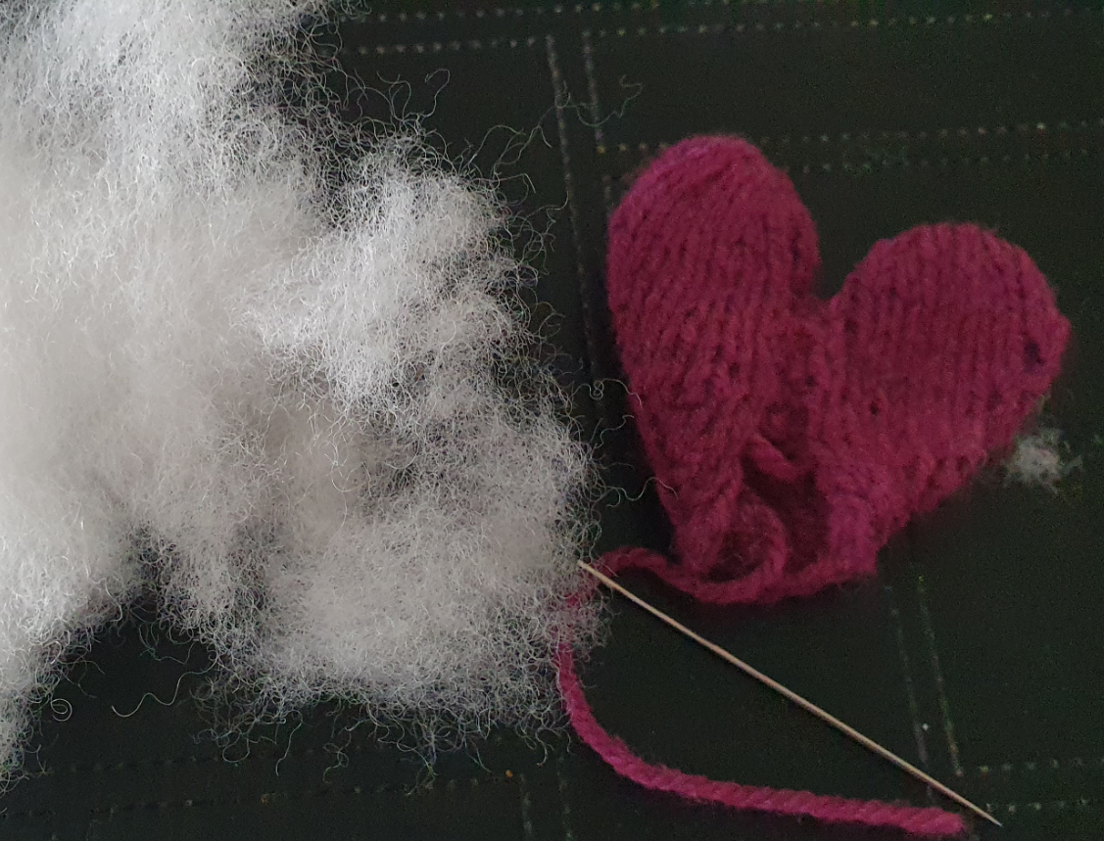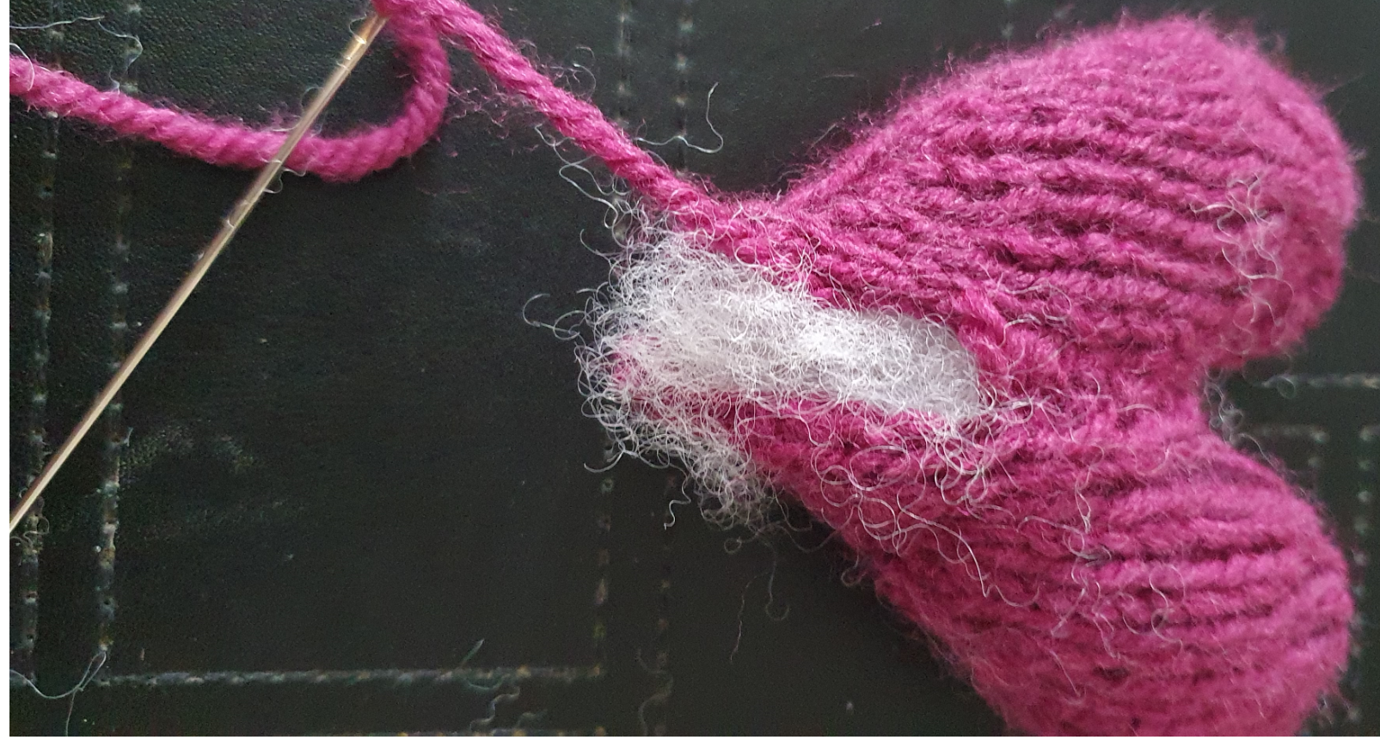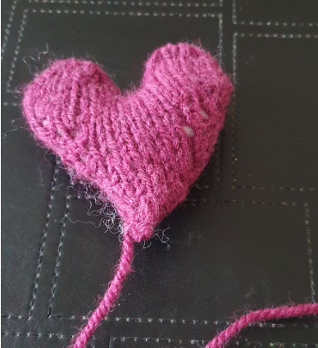

Abbreviations;
K1 ( knit one)
K2t ( knit two stiches together)
M1 (make one extra stitch)

