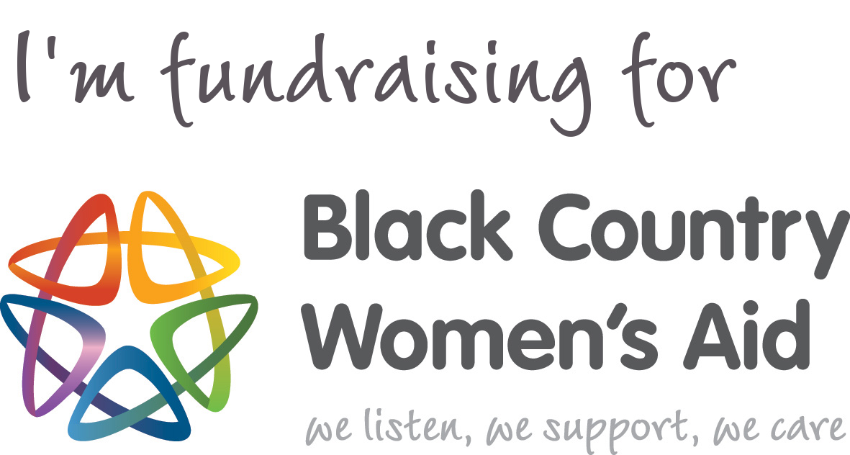

www.blackcountrywomensaid.co.uk

Registered charity 1032298



**Turn £1 into £1.25 without spending an extra penny!**

If you are a UK tax payer and would like to ‘gift aid’ your donation, please tick the Gift Aid column and provide us with your full name, home address and postcode. Read the declaration at the bottom of the page before ticking.

**SPONSORSHIP FORM**

Please sponsor me, ____________________________

To __________________________________________

in aid of Black Country Women’s Aid

**Black Country Women’s Aid (BCWA)** supports over 8000 women, children and men a year who are affected by domestic abuse, sexual violence, human trafficking and sexual exploitation.

**Your donation can help victims of abuse to rebuild their lives:**

**£4** = a bus ticket to help a woman escape her abuser and reach safe refuge

**£10** = an emergency food parcel for a mother and children’s first days in refuge

**£20** = an hour’s staffing for our 24-hour helpline

**£30** = a specialist counselling session for a victim of rape

**£40** = interpreting services for women trafficked to the UK for sexual exploitation

**£50 =** an awareness raising session for young people on teenage relationship abuse

**£100 =** a Christmas party for children in refuge

**£500** = a week of arts therapy for children affected by domestic abuse

**£1000** = printing 1000 Survivors’ Guides for victims of rape and sexual abuse and their friends and family

|  |  |  |  |  |  |
| --- | --- | --- | --- | --- | --- |
| Full Name  (First name and surname) | Home address. Essential if you are Gift Aiding your donation; please don't put your work address here | Postcode | Amount £ | Date paid | Gift Aid? √ |
|  |  |  |  |  |  |
|  |  |  |  |  |  |
|  |  |  |  |  |  |
|  |  |  |  |  |  |
|  |  |  |  |  |  |
|  |  |  |  |  |  |
|  |  |  |  |  |  |

If I have ticked the box headed ‘Gift Aid? **√**’, I confirm that I am a UK Income or Capital Gains taxpayer. I have read this statement and want the charity named above to reclaim tax on my donation. I understand that I must pay an amount of Income Tax and/or Capital Gains Tax in the tax year at least equal to the amount of tax that all the charities I donate to, will reclaim on my gifts for that tax year. I understand that other taxes such as VAT and Council Tax do not qualify. I understand the charity will reclaim 25p of tax on every £1 that I have given.



**Turn £1 into £1.25 without spending an extra penny!**

If you are a UK tax payer and would like to ‘gift aid’ your donation, please tick the Gift Aid column and provide us with your full name, home address and postcode. Read the declaration at the bottom of the page before ticking.

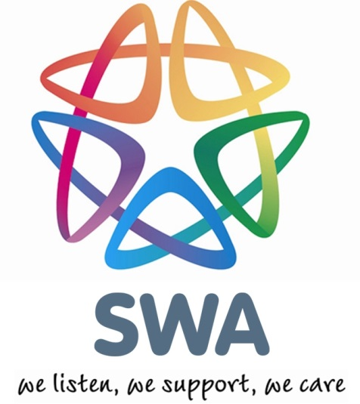

**SPONSORSHIP FORM (CONTINUED)**

Name: ________________________________

|  |  |  |  |  |  |
| --- | --- | --- | --- | --- | --- |
| Full Name  (First name and surname) | Home address (Only needed if you are Gift Aiding your donation), Please don't put your work address here) | Postcode | Amount £ | Date paid | Gift Aid?  √ |
|  |  |  |  |  |  |
|  |  |  |  |  |  |
|  |  |  |  |  |  |
|  |  |  |  |  |  |
|  |  |  |  |  |  |
|  |  |  |  |  |  |
|  |  |  |  |  |  |
|  |  |  |  |  |  |

If I have ticked the box headed ‘Gift Aid? **√**’, I confirm that I am a UK Income or Capital Gains taxpayer. I have read this statement and want the charity named above to reclaim tax on my donation. I understand that I must pay an amount of Income Tax and/or Capital Gains Tax in the tax year at least equal to the amount of tax that all the charities I donate to, will reclaim on my gifts for that tax year. I understand that other taxes such as VAT and Council Tax do not qualify. I understand the charity will reclaim 25p of tax on every £1 that I have given.





**Turn £1 into £1.25 without spending an extra penny!**

If you are a UK tax payer and would like to ‘gift aid’ your donation, please tick the Gift Aid column and provide us with your full name, home address and postcode. Read the declaration at the bottom of the page before ticking.

**SPONSORSHIP FORM (CONTINUED)**

Name: ________________________________

|  |  |  |  |  |  |
| --- | --- | --- | --- | --- | --- |
| Full Name  (First name and surname) | Home address (Only needed if you are Gift Aiding your donation), Please don't put your work address here) | Postcode | Amount £ | Date paid | Gift Aid?  √ |
|  |  |  |  |  |  |
|  |  |  |  |  |  |
|  |  |  |  |  |  |
|  |  |  |  |  |  |
|  |  |  |  |  |  |
|  |  |  |  |  |  |
|  |  |  |  |  |  |
|  |  | **Total** |  |  |  |

If I have ticked the box headed ‘Gift Aid? **√**’, I confirm that I am a UK Income or Capital Gains taxpayer. I have read this statement and want the charity named above to reclaim tax on my donation. I understand that I must pay an amount of Income Tax and/or Capital Gains Tax in the tax year at least equal to the amount of tax that all the charities I donate to, will reclaim on my gifts for that tax year. I understand that other taxes such as VAT and Council Tax do not qualify. I understand the charity will reclaim 25p of tax on every £1 that I have given.