Getting the Right Support: Leaflet and poster range
We produce a range of leaflets and posters to raise awareness of BCWA’s services supporting people experiencing domestic abuse in the Black Country (Sandwell, Dudley and Walsall).
A6 Postcards: Don’t Suffer in Silence
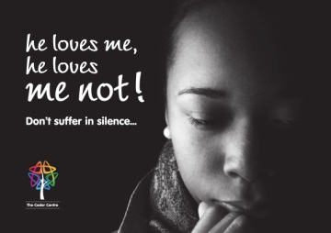 | 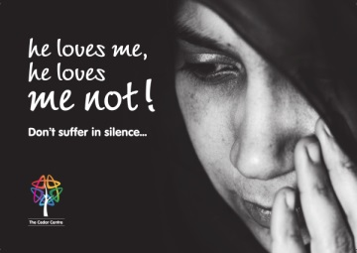 | 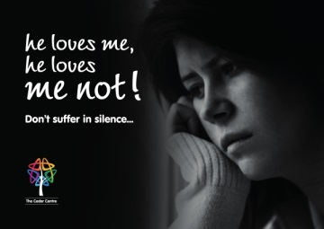 | All designs have basic information on domestic abuse and The Cedar Centre’s contact details on the reverse.
Postcard 1 | Postcard 2 | Postcard 3
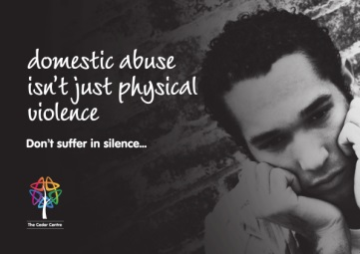
Postcard 4: DV & men | Postcard 5: DV & children | Postcard 6: LGBTT focus

Leaflet: IDVA Services |  |  | A3 posters
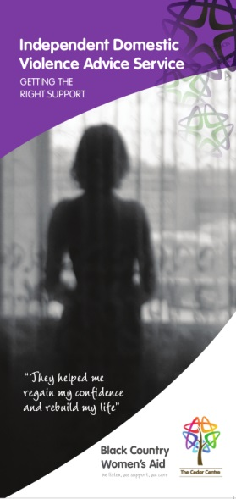 | Getting the Right Support: DL folded 4-panel leaflet with detailed information about domestic abuse and the support an IDVA can provide. |  | 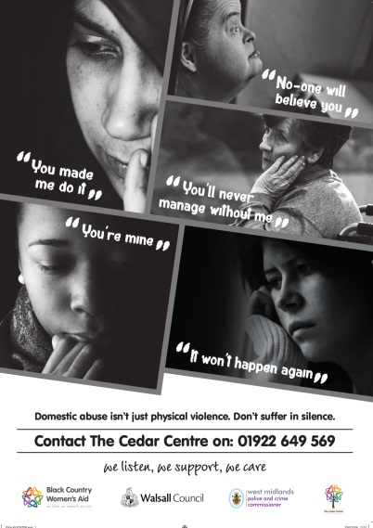 | Poster 1:  Women and DV
 |  |  | 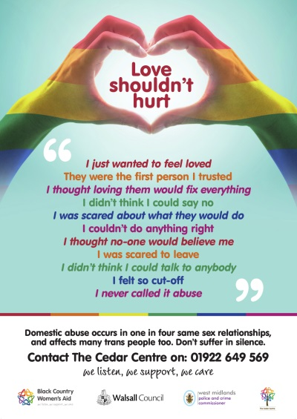 | Poster 2:  LGBTT focus
If you would like to place an order for print to display in settings that you work in, please use the form on the next page.

The Cedar Centre: Leaflet Order form
Quantity required
A6 Postcards
Postcard 1
Postcard 2
Postcard 3
Postcard 4: DV & men
Postcard 5: DV & children
Postcard 6: LGBTT focus
A3 Posters
Poster 1: DV and women
Poster 2: LGBTT focus
Leaflet: IDVA Services

We offer services across Sandwell, Dudley and Walsall and produce leaflets targeting each area. Please place an X in the box next to the area you work in so we can make sure that you receive the correct print.
Sandwell |  | Dudley |  | Walsall

Your Details
Name
Job Title
Organisation
Telephone
Email
Delivery Address
Postcode

Please return this form to kat@blackcountrywomensaid.co.uk

